Screenshots:

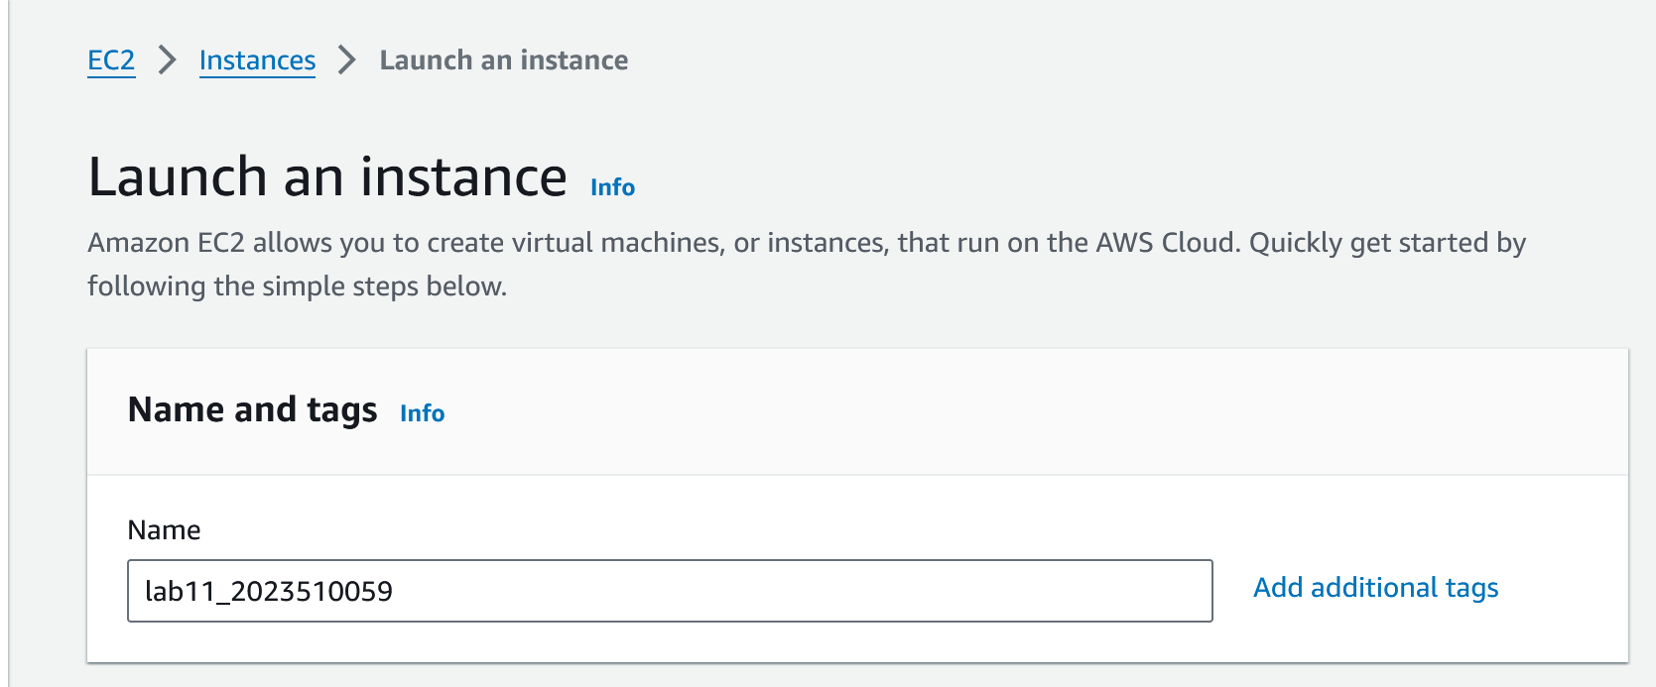

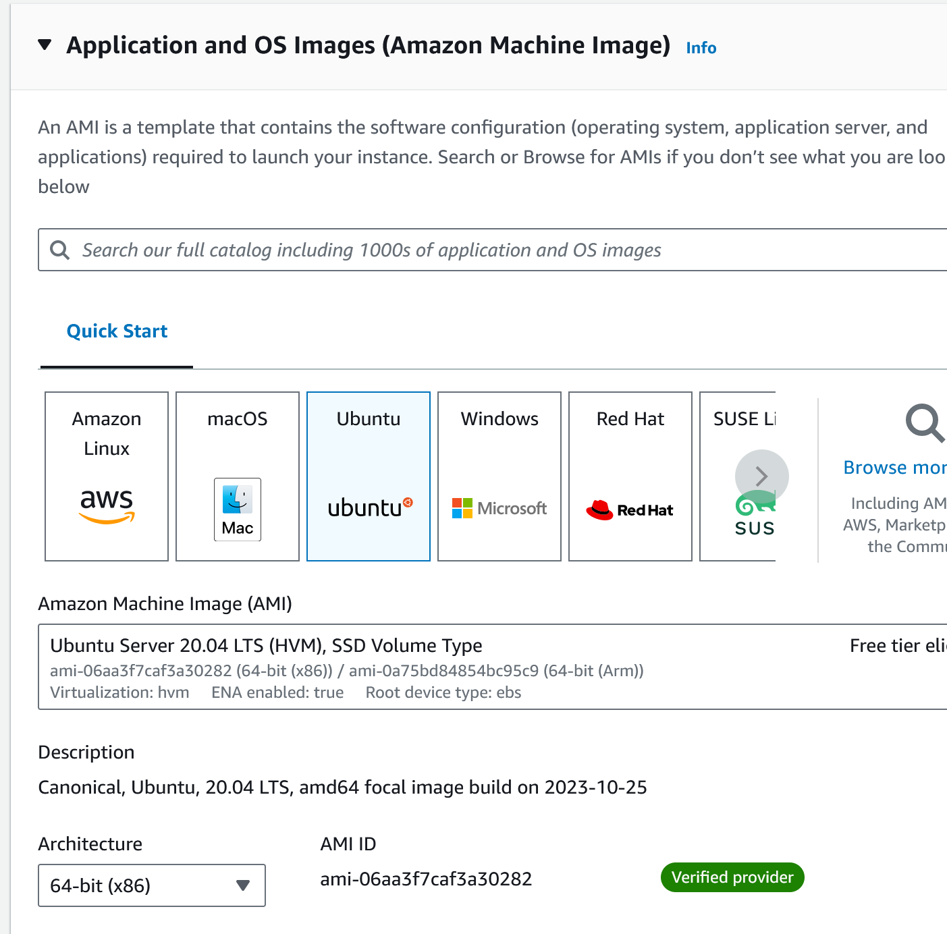

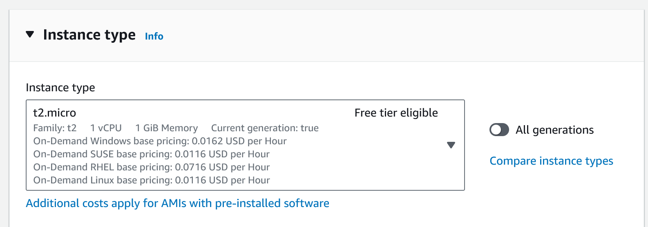

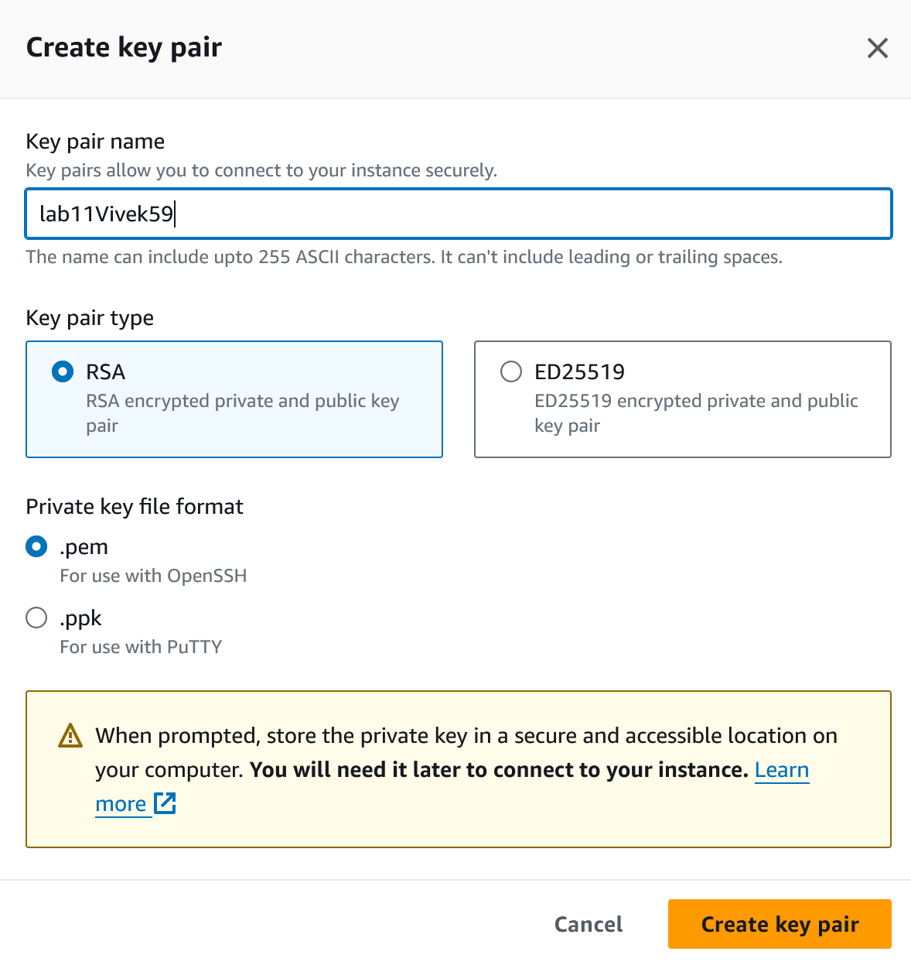

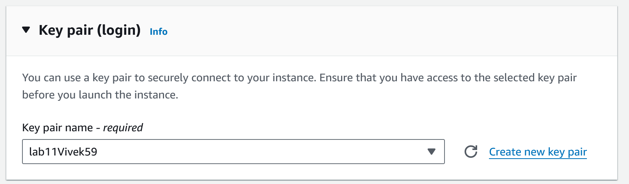

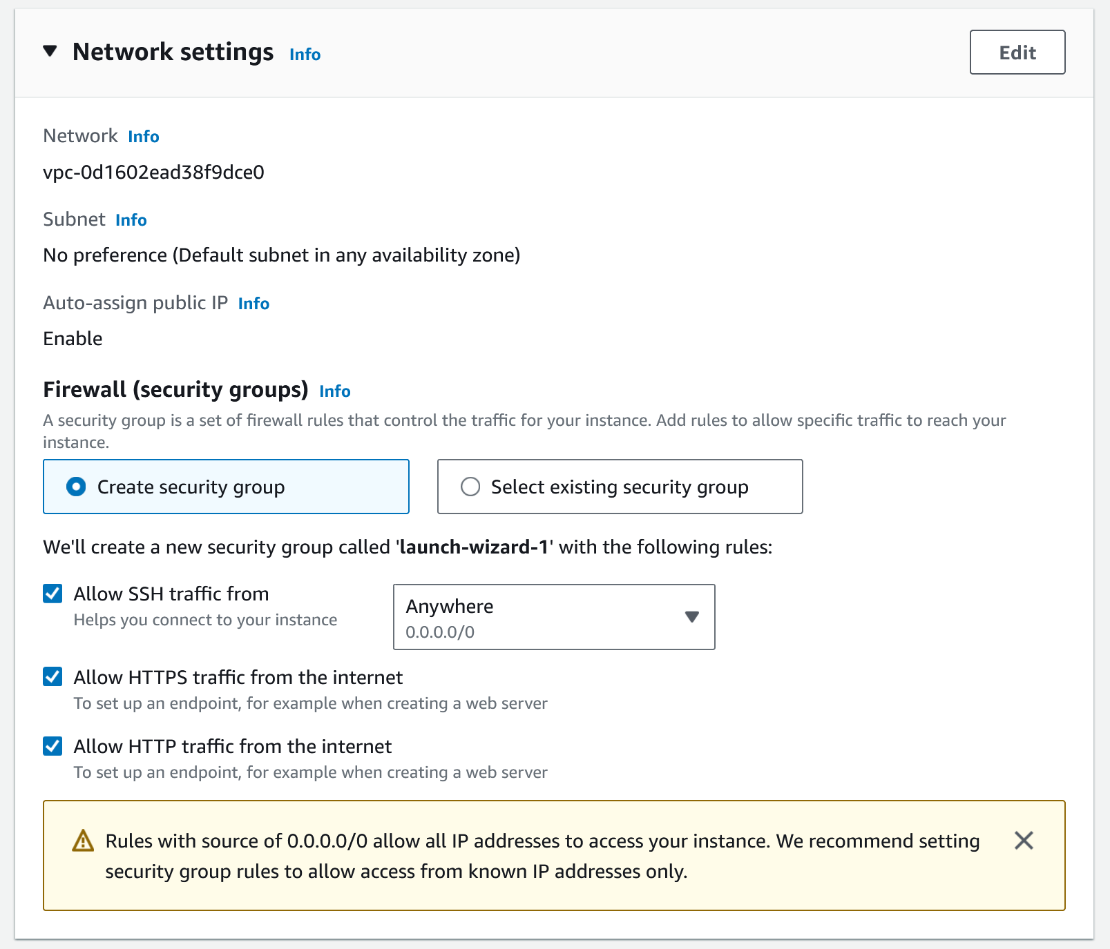

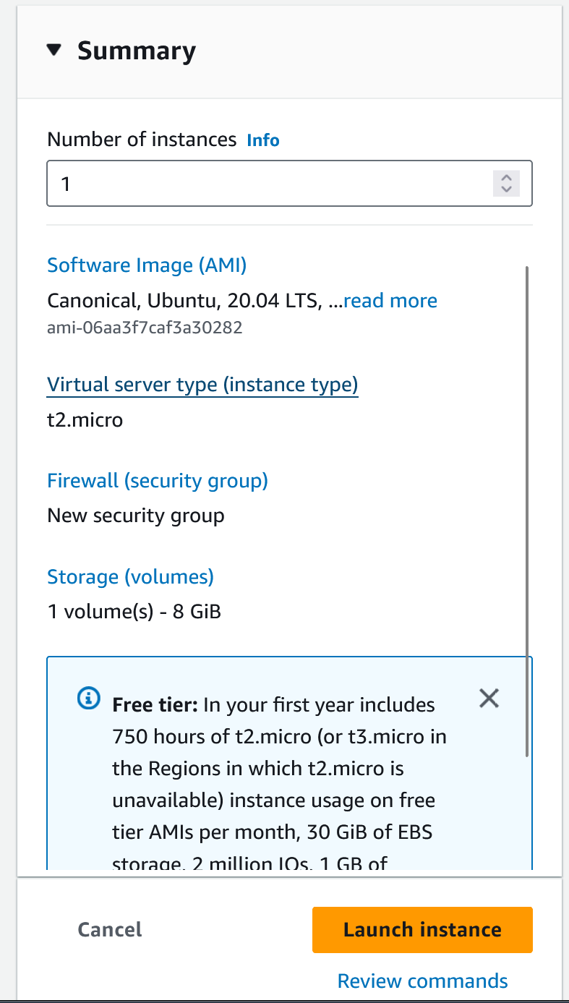

**API Calls to the instance:**

{

"MaxCount": 1,

"MinCount": 1,

"ImageId": "ami-06aa3f7caf3a30282",

"InstanceType": "t2.micro",

"KeyName": "lab11Vivek59",

"EbsOptimized": false,

"NetworkInterfaces": [

{

"AssociatePublicIpAddress": true,

"DeviceIndex": 0,

"Groups": [

"<groupId of the new security group created below>"

]

}

],

"TagSpecifications": [

{

"ResourceType": "instance",

"Tags": [

{

"Key": "Name",

"Value": "lab11_2023510059"

}

]

}

],

"MetadataOptions": {

"HttpTokens": "required",

"HttpEndpoint": "enabled",

"HttpPutResponseHopLimit": 2

},

"PrivateDnsNameOptions": {

"HostnameType": "ip-name",

"EnableResourceNameDnsARecord": true,

"EnableResourceNameDnsAAAARecord": false

}

}

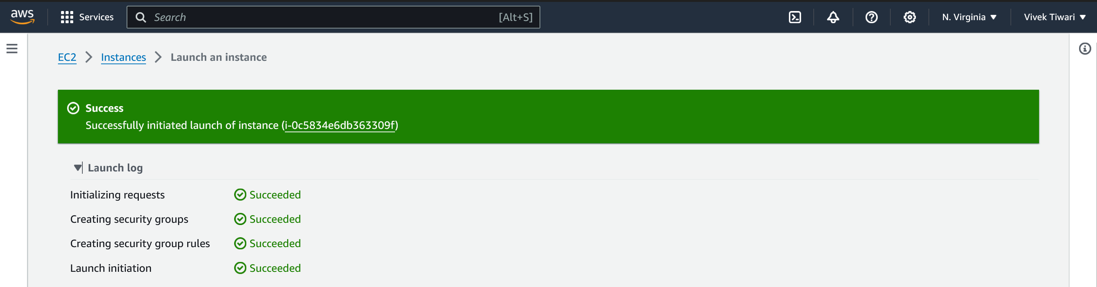

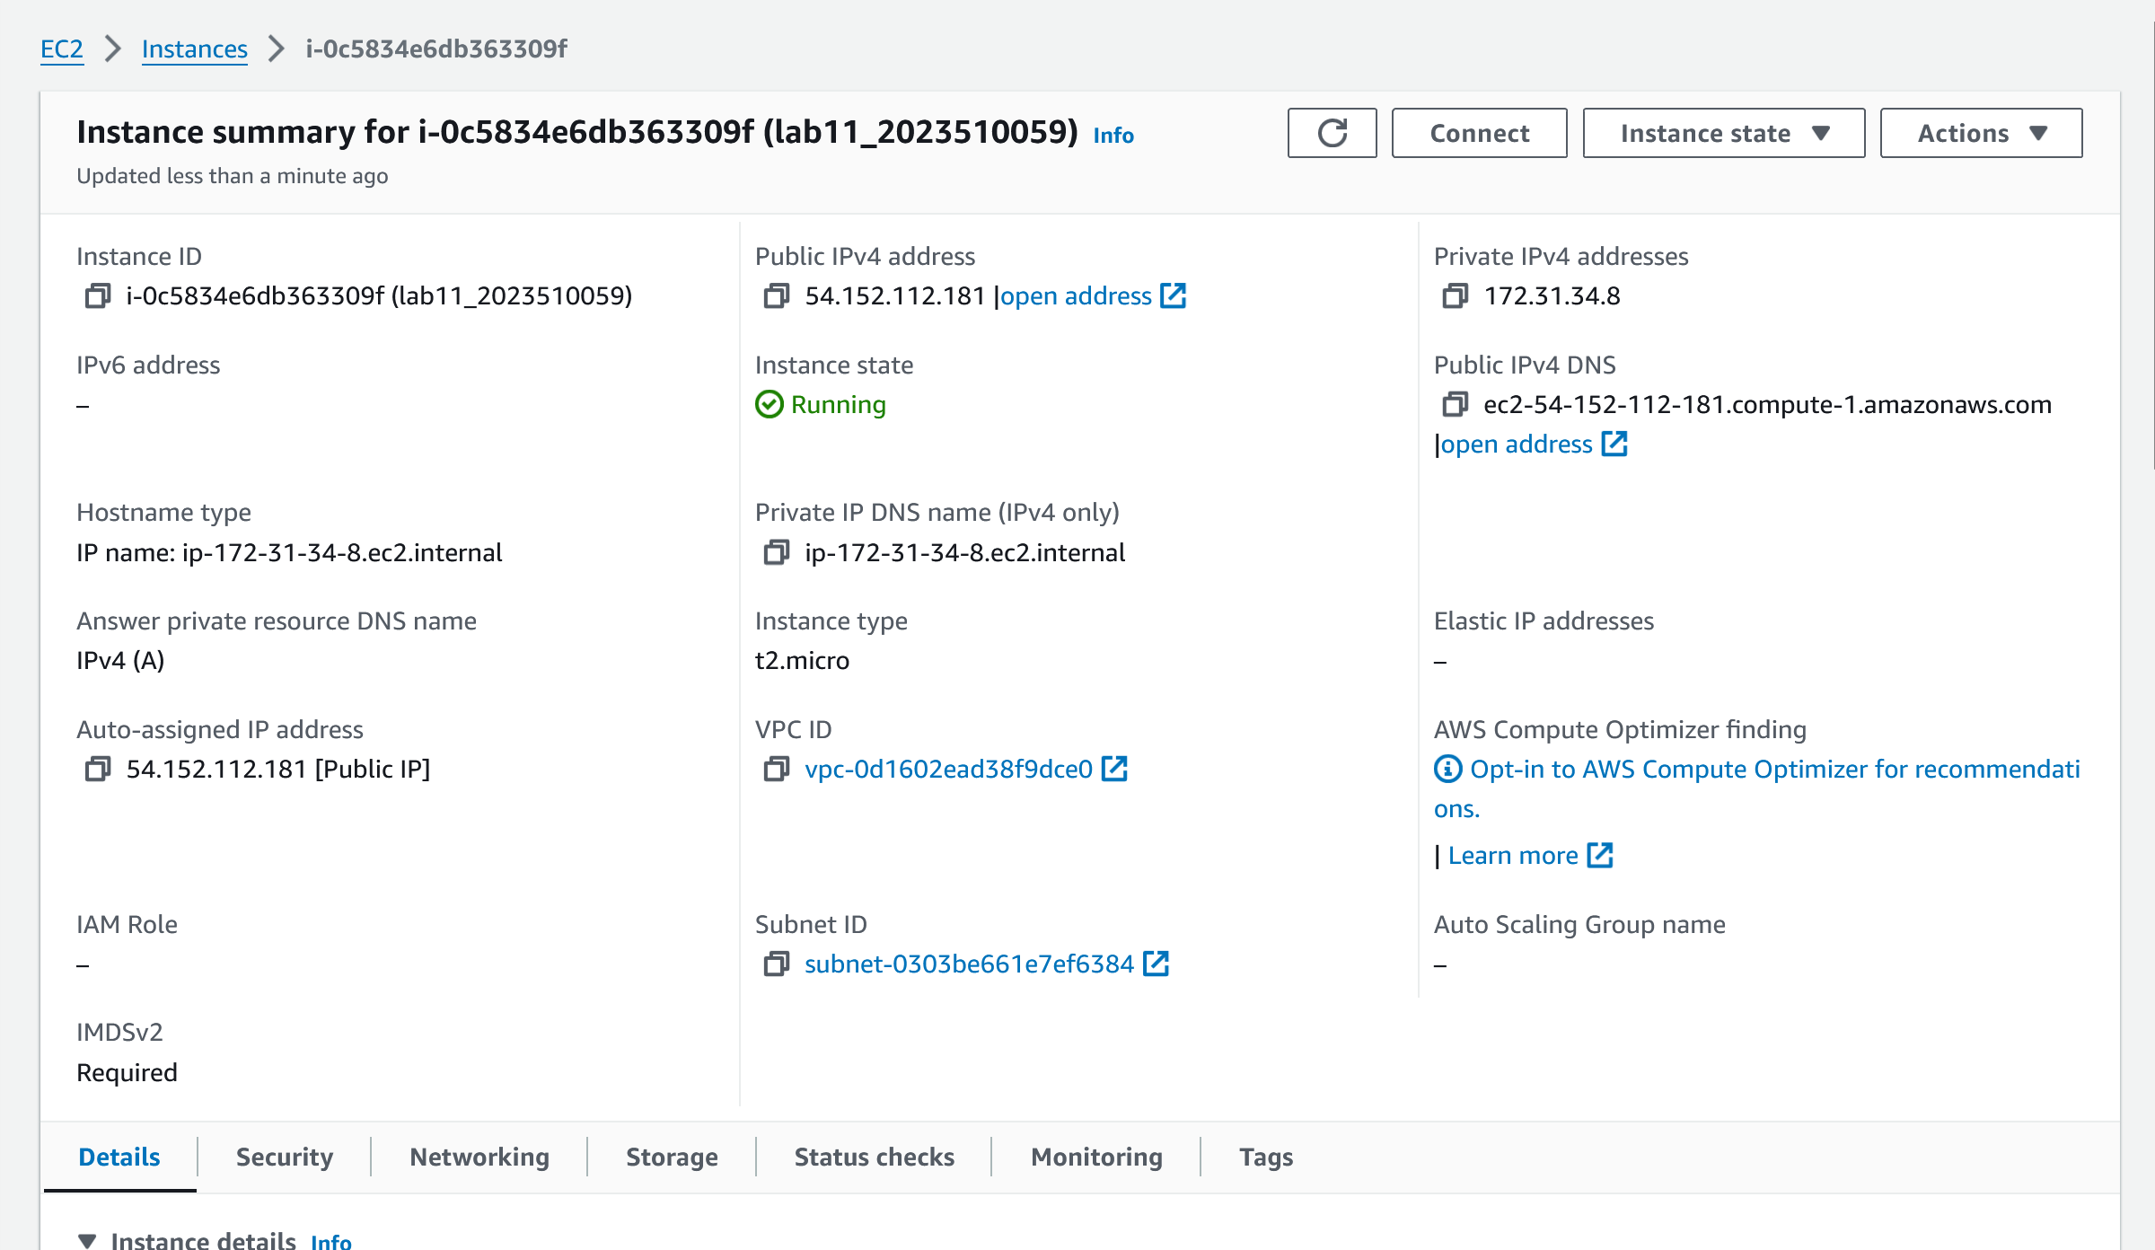

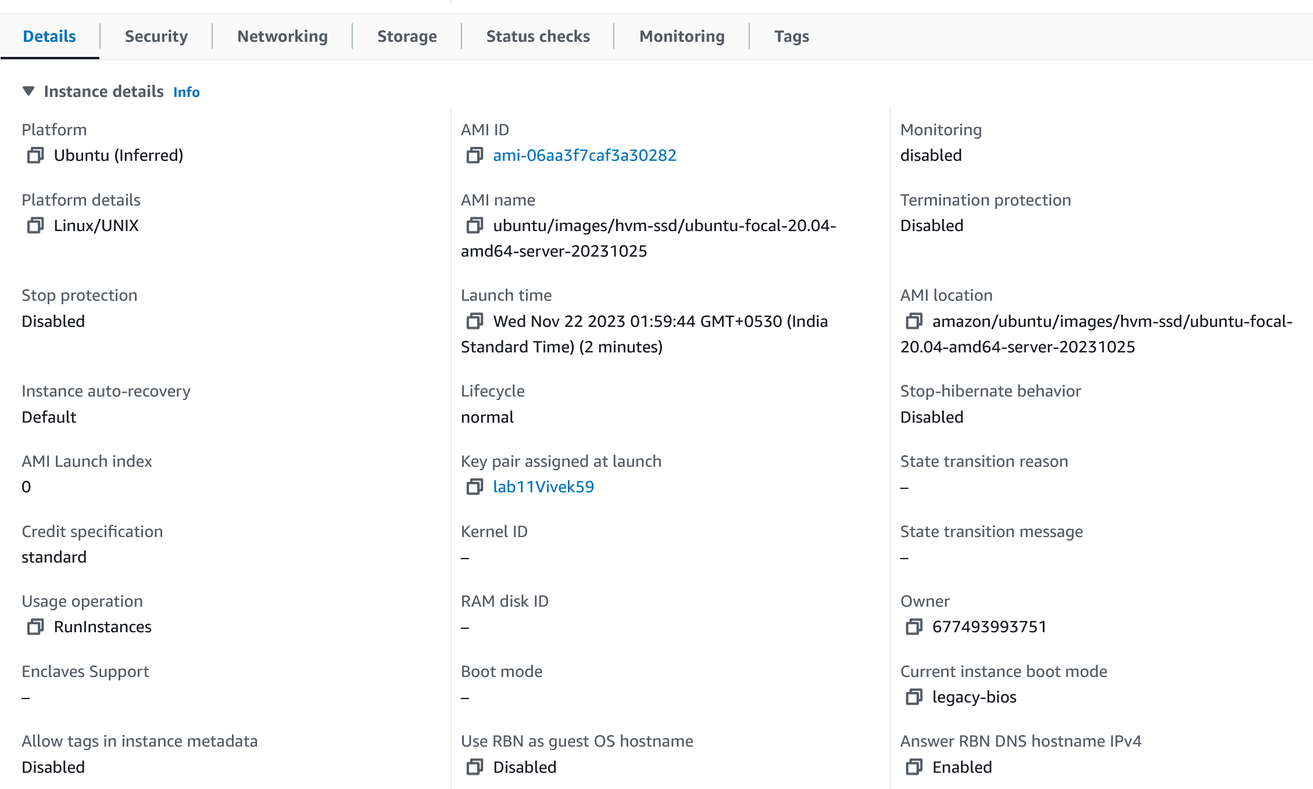

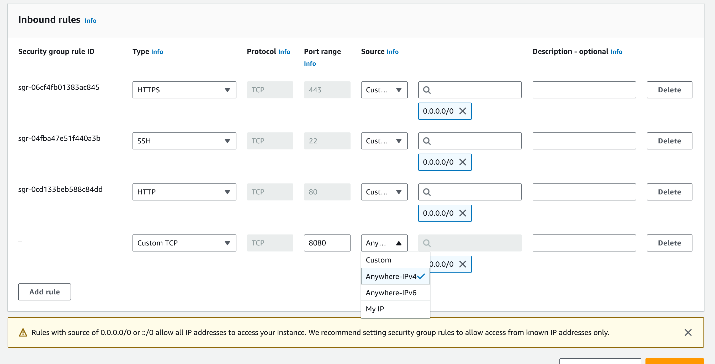

om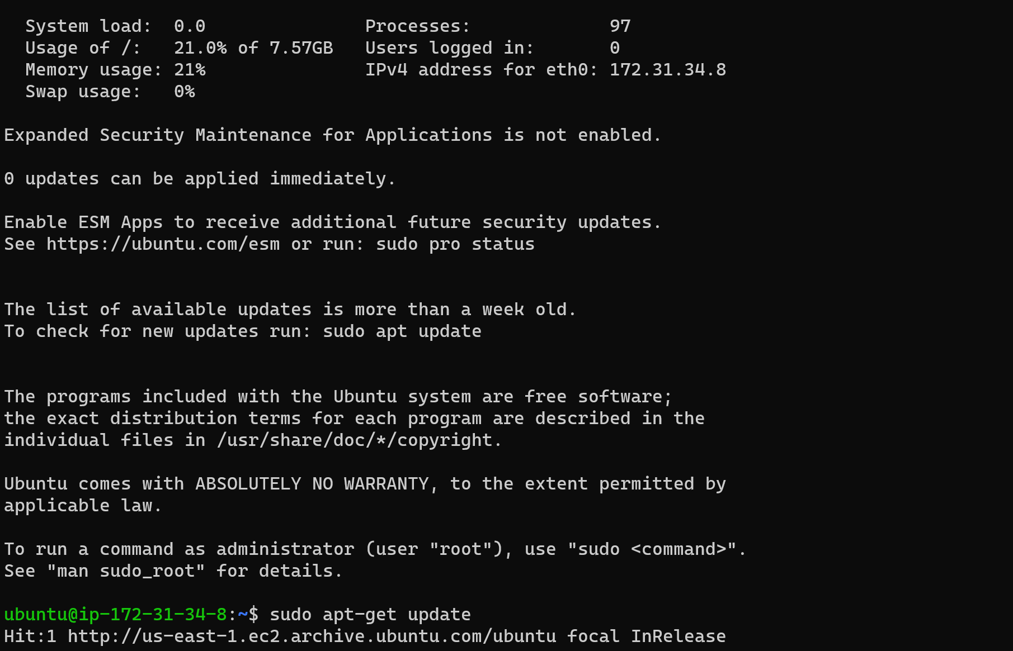

Now adding Jenkins repository for ubuntu:

Command 1:

sudo wget -O /usr/share/keyrings/jenkins-keyring.asc \

https://pkg.jenkins.io/debian-stable/jenkins.io-2023.key

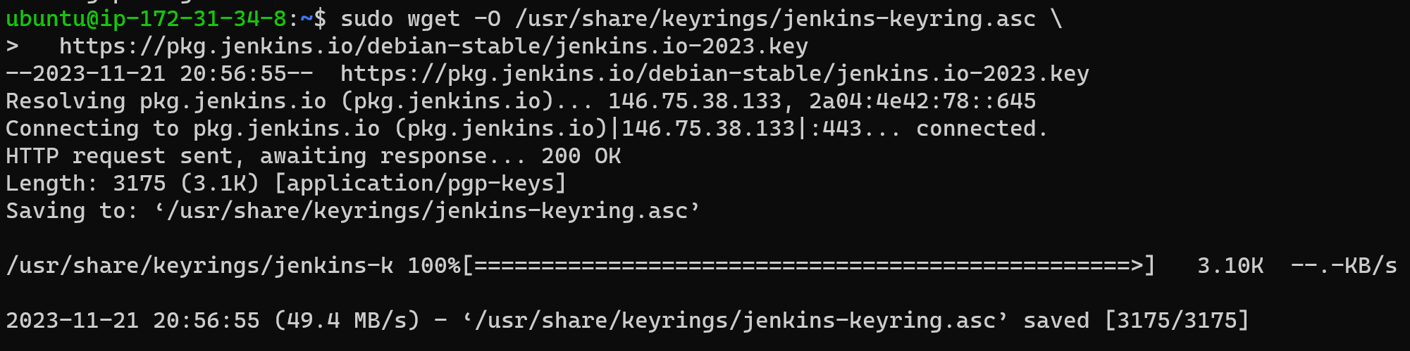

Command 2:

echo deb [signed-by=/usr/share/keyrings/jenkins-keyring.asc] \

https://pkg.jenkins.io/debian-stable binary/ | sudo tee \

/etc/apt/sources.list.d/jenkins.list > /dev/null



Now run ‘sudo apt-get update’ to update the Jenkins repository

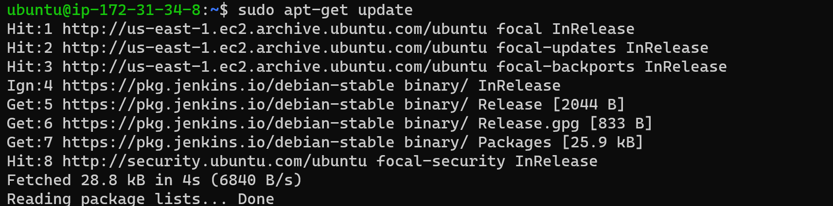

Before installing Jenkins, install openjdk -17 using the command ‘sudo apt install fontconfig openjdk-17-jre’

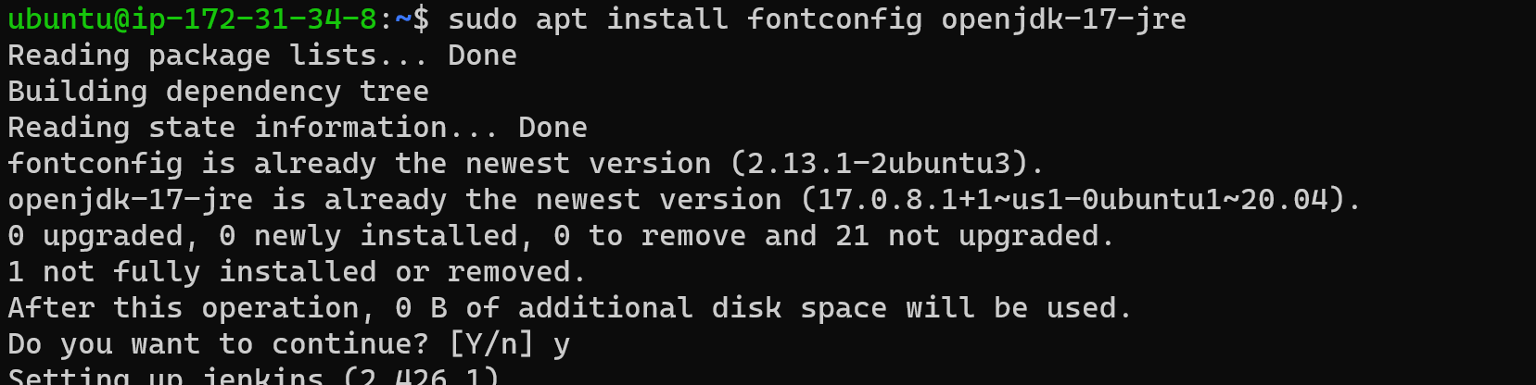

Now install Jenkins using the command ‘sudo apt-get install Jenkins -y’

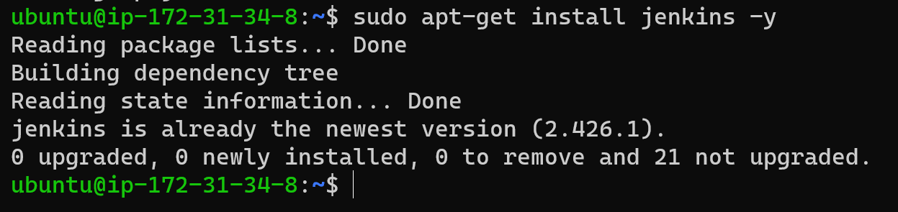

Now run the command ‘sudo systemctl enable jenkins’

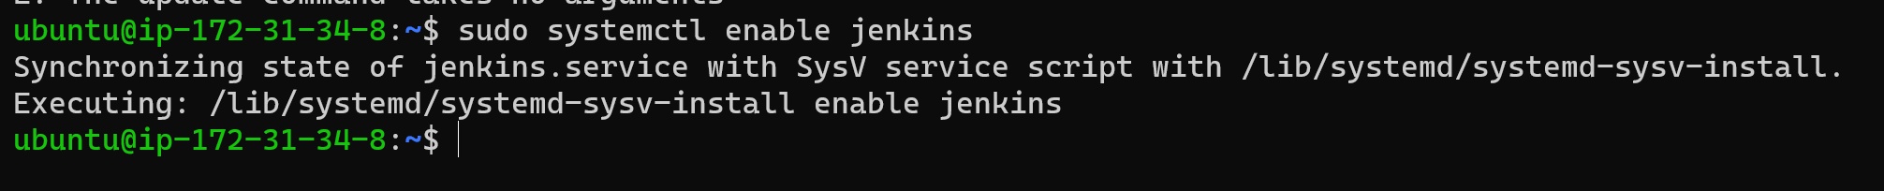

Now start Jenkins service using the command ‘sudo systemctl start Jenkins’

To check if Jenkins is running or not, use the command ‘sudo systemctl status jenkins’

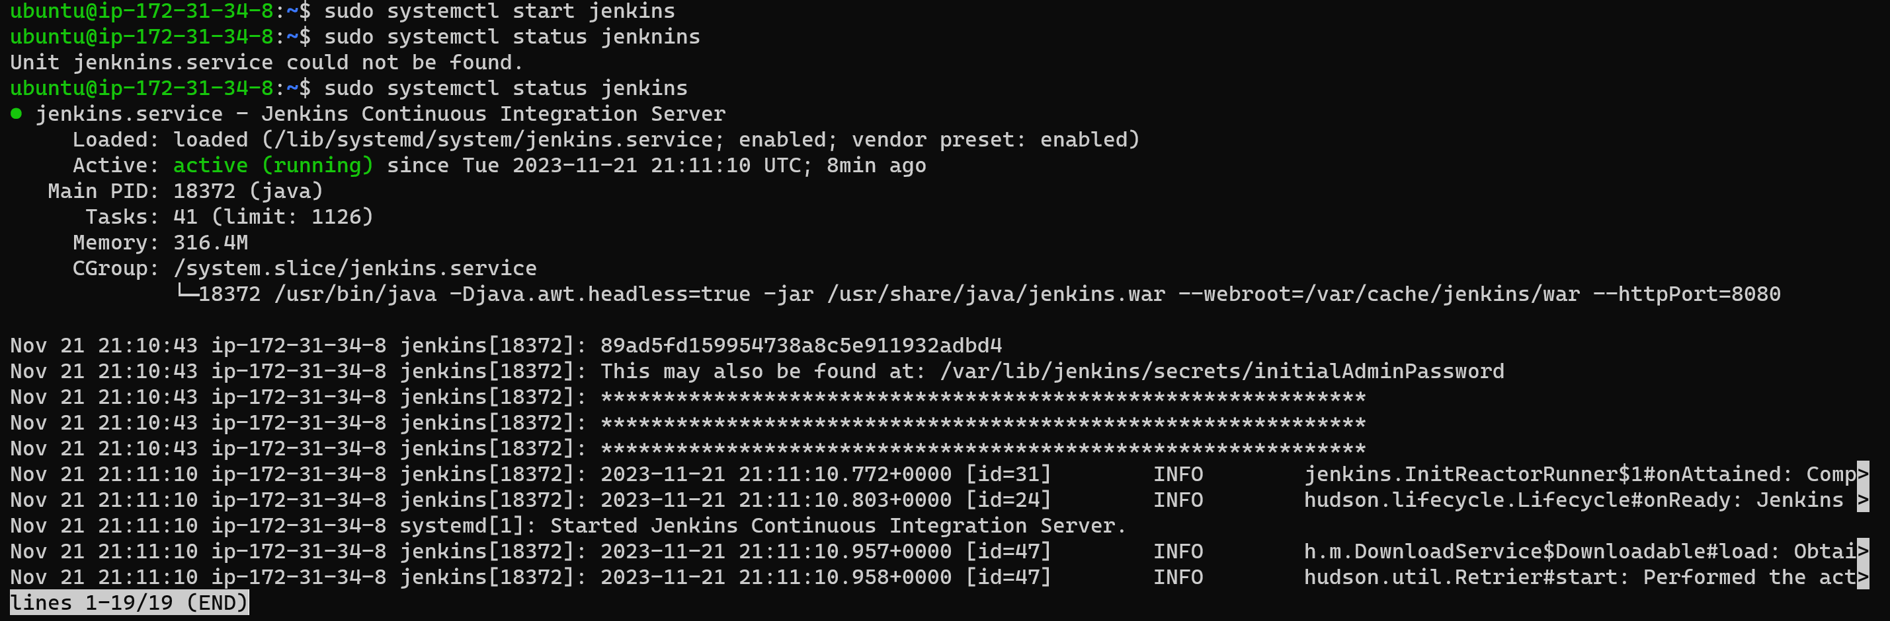

Now copy the ip address mentioned under the ec2 connect tab

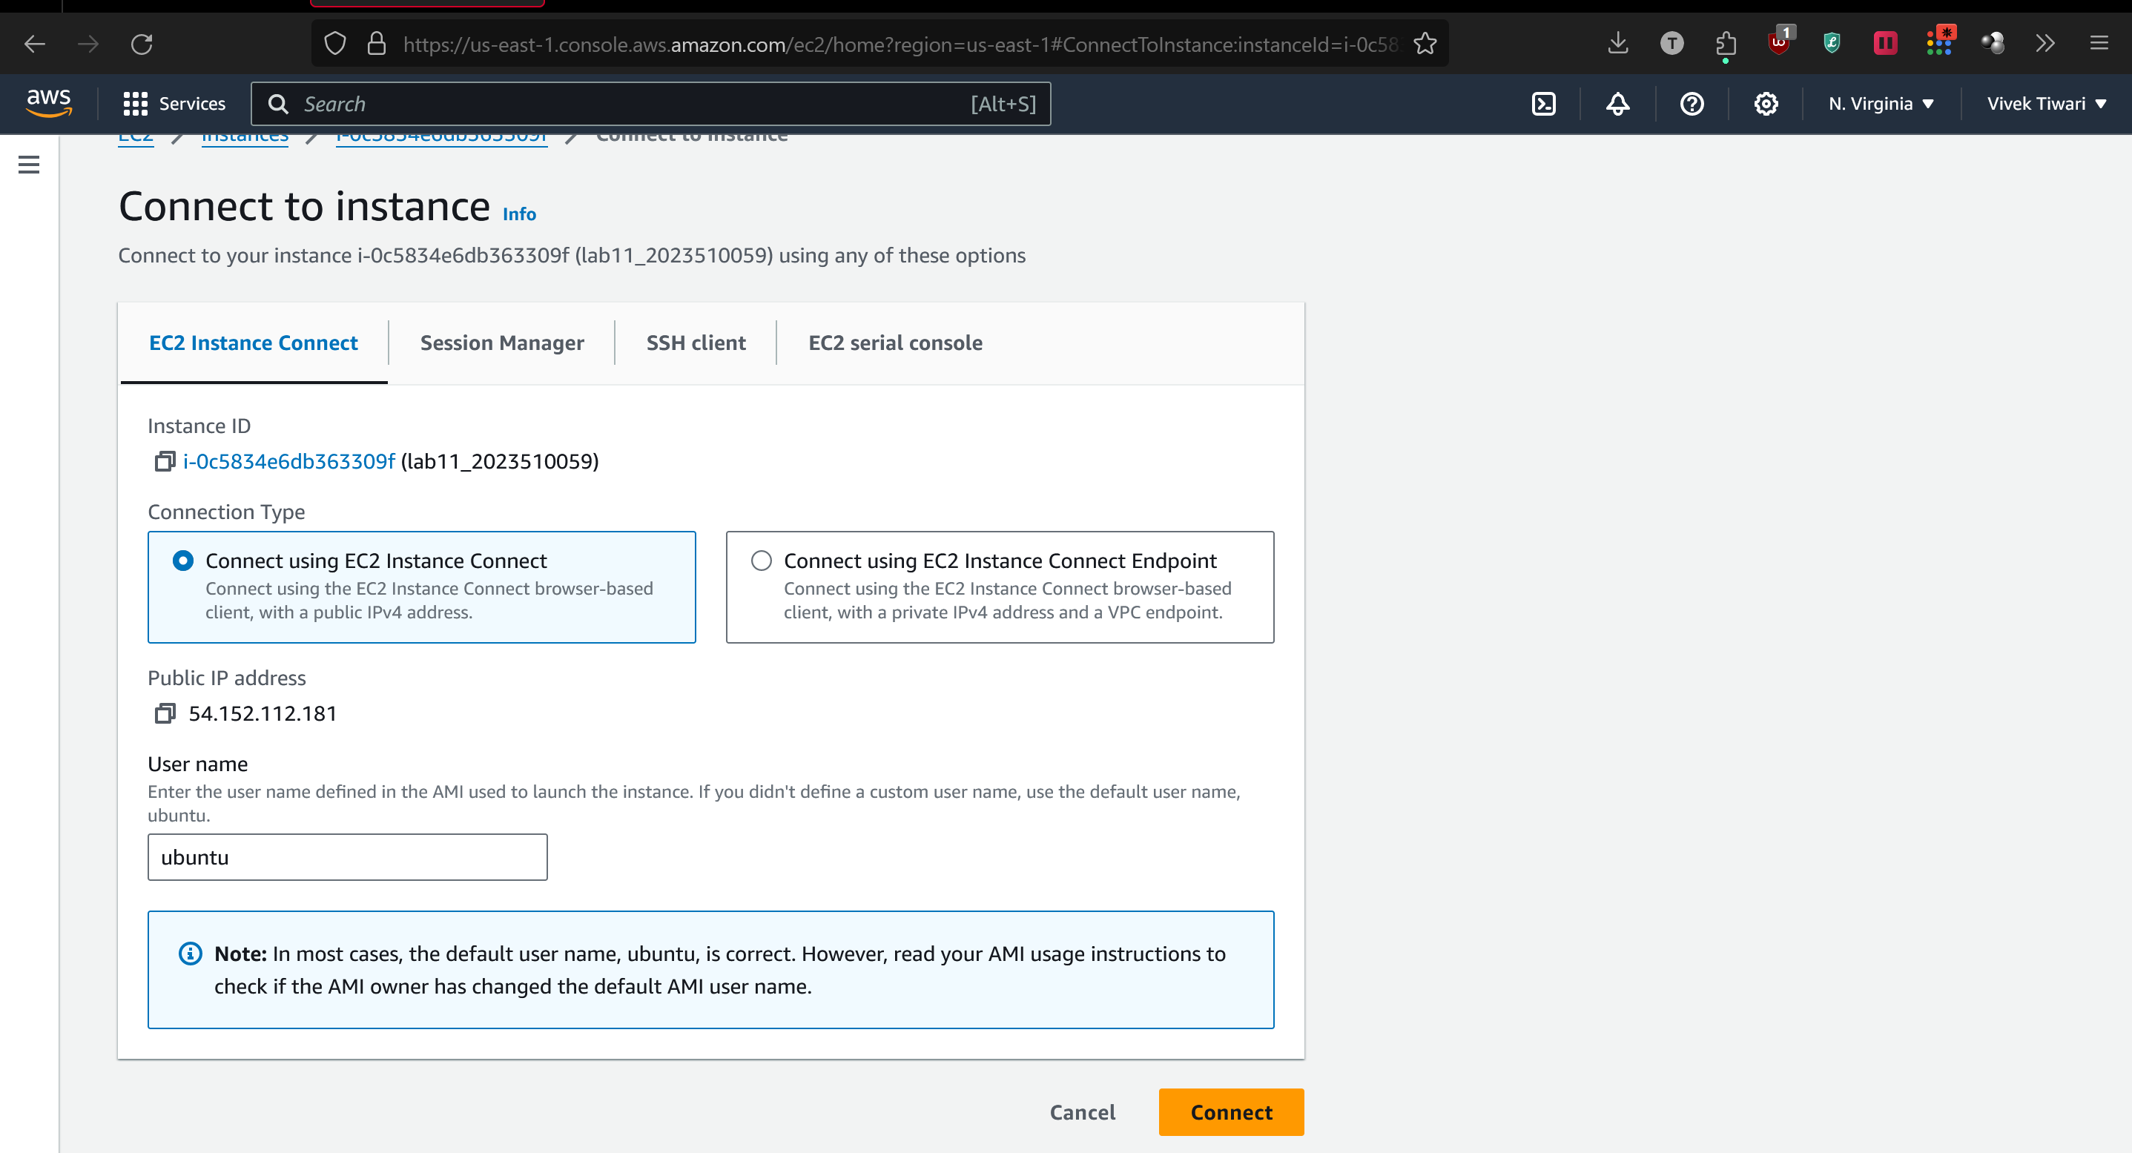

Append the port 8080 to the IP address as we had previously defined:

54.152.112.181:8080, and paste the IP address in your browser.

The browser should load unlock Jenkins page as below.

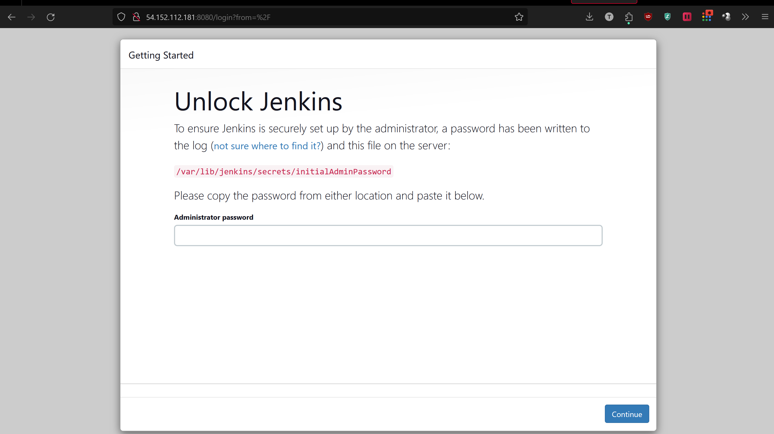

Copy the path:

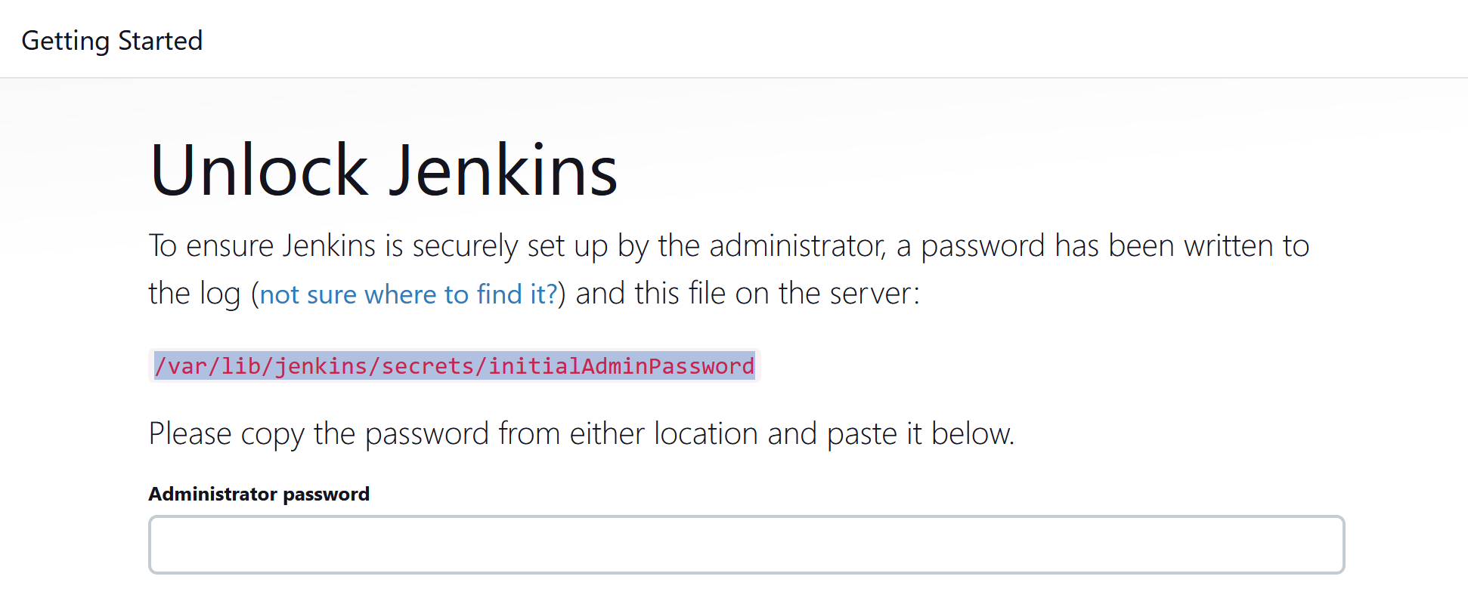

Run the command ‘sudo cat <path>’. This command will return a password.



After entering the password, select install suggested plugins:

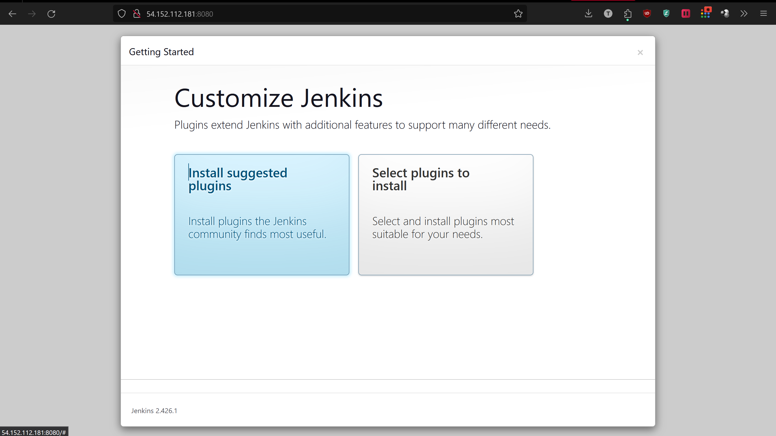

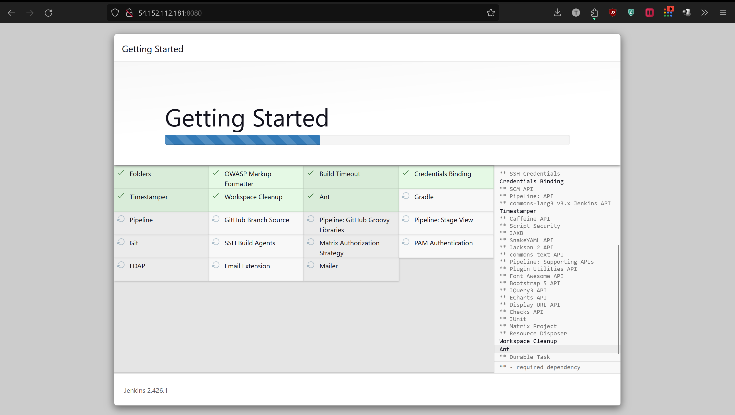

Now create an admin user:

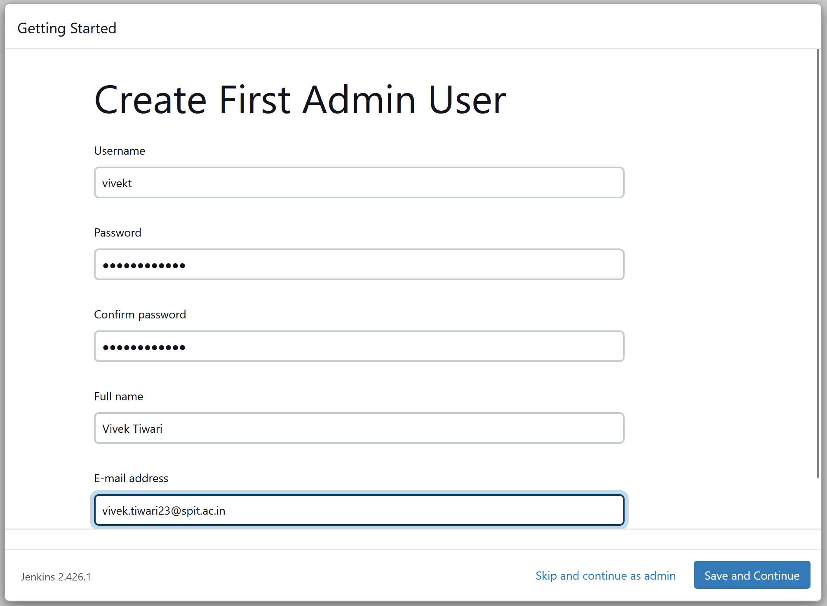

Make sure to copy your Jenkins URL on the next step after saving the user details.

Once done, you’ll be greeted with the following message.

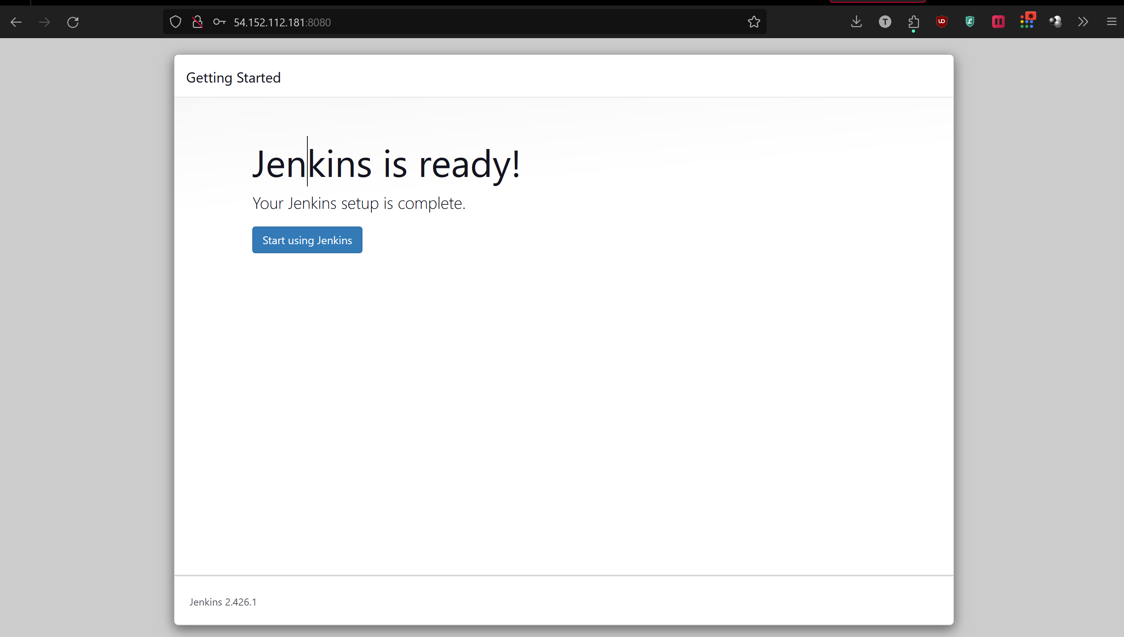

Now Jenkins is ready to use:

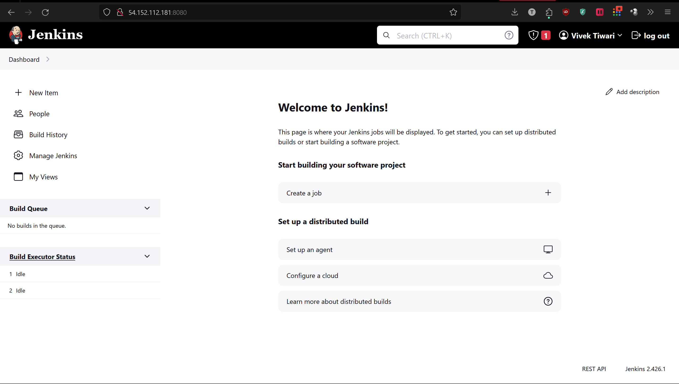

Click on new item:  
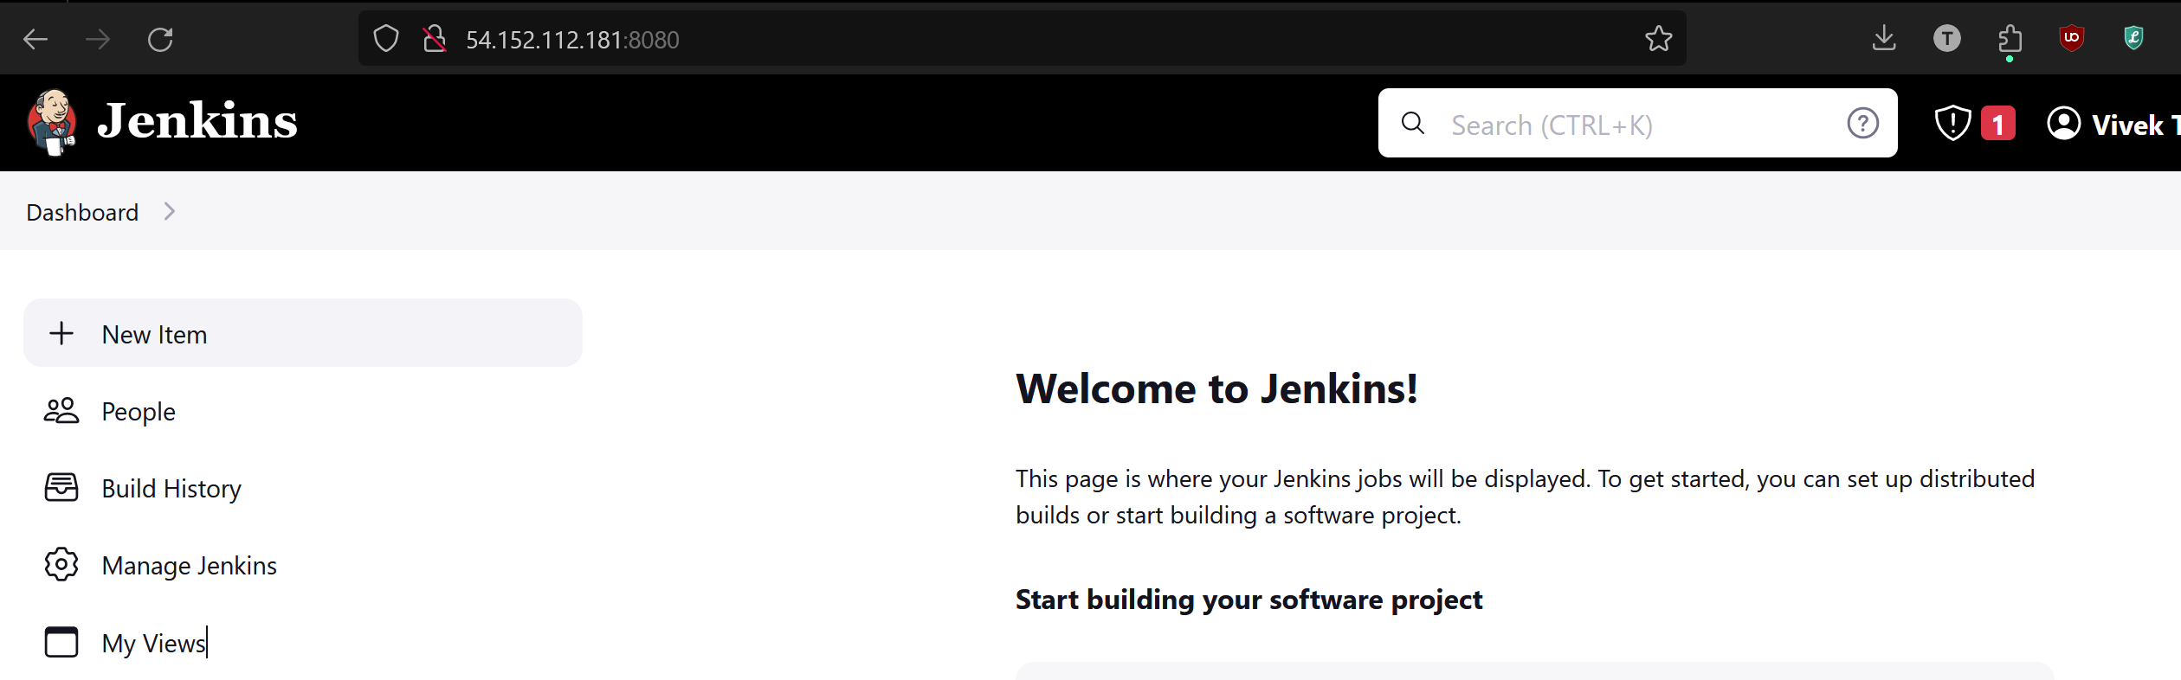

Now enter any suitable name for your pipeline and select the pipeline options from below:

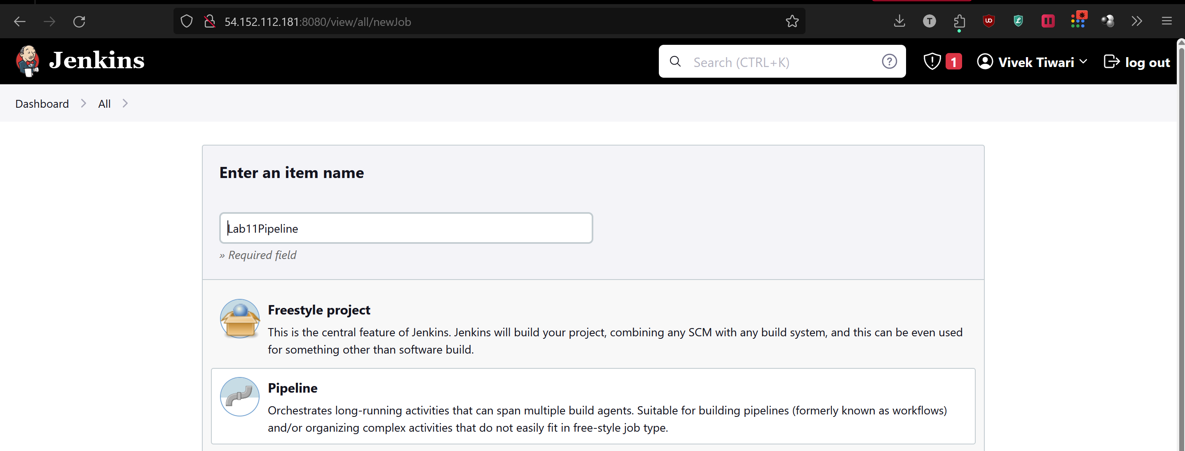

On the next page, scroll down to Pipeline, and select ‘hello world’ from the top right drop down menu.

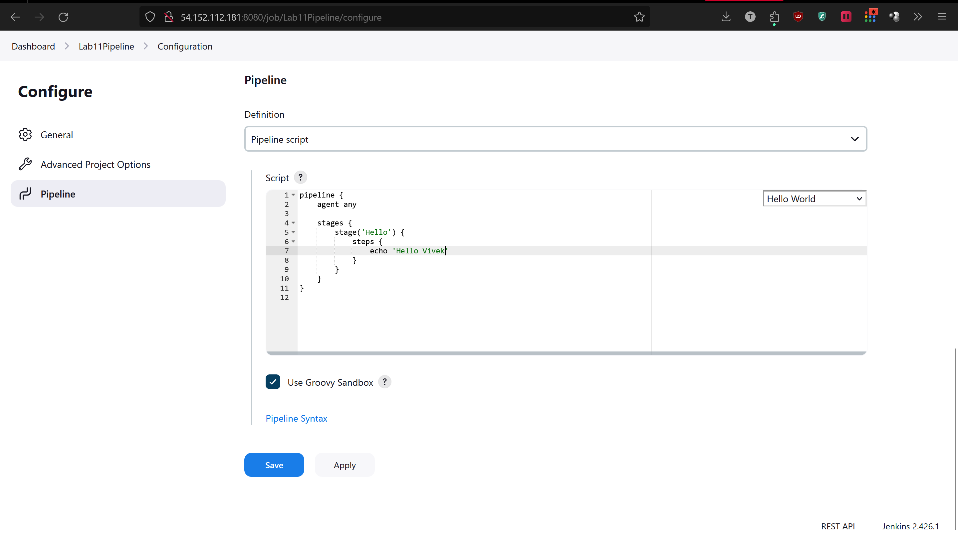

After saving it, go back to your dashboard and schedule a build:

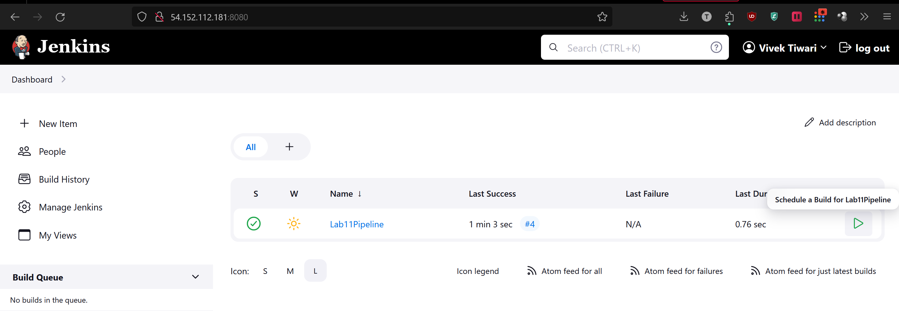

Now you can check if your pipeline is functional or not:

